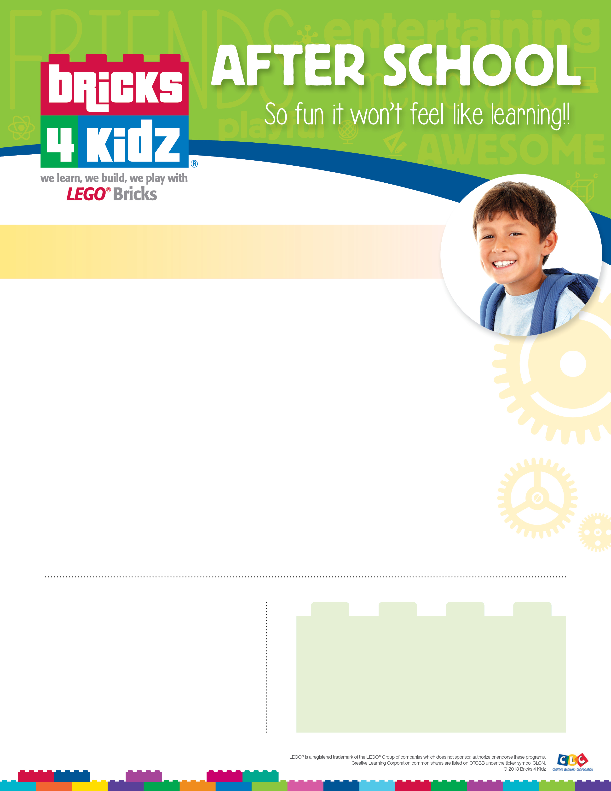

**Classes Provided by**

**Bricks 4 Kidz of Hunterdon-Somerset**

**908-638-0093**

**www.bricks4kidz.com/HunterdonSomerset**

**Wednesday 3:15 – 4:20pm**

**Cost: $128.00 for an 8 week session**

**Class dates: January 10th, 17th, 24th, 31st, February 7th, 14th, 21st & 28th.**

**Register Online:**

[https://www.bricks4kidz.com/HunterdonSomerset](https://my.bricks4kidz.com/index.php?action=enrolling&record=143)

We will be introducing another new theme at Woodland for our winter session. The theme will focus on the E in STEM; engineering. Students will be introduced to different engineering concepts each week. The 8 - week session will include models based on a **Bascule (modern day drawbridge) bridge, a truss bridge, an elevator and an** **electric car** to name a few of the models in our **Engineering Adventure** theme. The students will have time to create their own structures as well, using the engineering concepts discussed during the weekly discussions. The classes are both educational and fun; a great combination.

**Sibling 10% discount code: 57D5D08B460F7**

**Sponsored by the Woodland PTO, which receives 10% of the tuition**

**Building with LEGO® bricks and learning-**

**Woodland After School Enrichment classes for 1st- 4th Grades**